ATRIUM TNA Brno Training School Blog Post

Lesley Davidson, Research Archaeologist: Data Scientist, The Discovery Programme

15/10/2024

Thanks to a grant provided by the [Transnational Access (TNA)](https://atrium-research.eu/tna-application-process/) scheme through the [ATRIUM project](https://atrium-research.eu), I was lucky enough to travel to Brno, Czechia to attend a summer school in computational archaeology focusing on the re-use and interoperability of archaeological data. The [atrium Brno Training School](https://petrpajdla.github.io/atRium/) took place from the 16th to the 20th of September 2024 and was held at the Institute of Archaeology, Czech Academy of Science.

Image: Location of the summer school – Institute of Archaeology, Czech Academy of Science, Brno, Czechia

Like my colleagues Eimear Meegan and Hannah Genders Boyd, who went on [Adventures in the Heart of Neolithic Orkney World Heritage Site](https://discoveryprogramme.ie/2024/09/12/orkney/), I also experienced disruptions to travel due to weather conditions. A record amount of rainfall to region caused many cancellations and delays in transportation. While storm Boris hindered sightseeing in Vienna en route to Brno, luckily it did not stop me nor my fellow participants from arriving to our final destination in time for the start of the summer school.

Image: Me and another participate, Nicky Garland from Archaeology Data Service, venturing out in the rain for a whirlwind walking tour of Vienna, Austria. Here we are outside of St. Stephen’s Cathedral.

Over the course of 5 days myself and 18 other participants from across Europe attended the summer school where we learned essential skills in R programming language. The summer school was hosted by the Archaeological Information System of the Czech Republic, Institute of Archaeology, Czech Academy of Science – AIS CR ([ARUB](https://www.arub.cz/en/)).

Image: The 19 participants along with the trainers catching a bit of sun on the roof terrace of the Institute during a well-deserved break from coding in R! Photo: copyright ARUB 2024

Day 1 began with a warm welcome from Petr Pajdla, the course coordinator who also introduced us to the course content and the team of trainers. The course then formally commenced with a detailed introduction to R and R workflows delivered by Petr Tkáč, which brought us up to lunch! After refuelling at small café offering vegan food made of local and seasonal ingredients, we were given a tour of the Archaeological Information System of the Czech Republic ([AIS CR](https://www.aiscr.cz/en/)) library and offices based within the institute. AIS CR are responsible for integrating digital resources relating to the archaeological record of Czechia and delivering this resource to the public with the FAIR data principles at its core.

Image: Olga Lečbychová, head of the archive giving us a tour of the AIS CR library at the institute.

The afternoon of Day 1 was dedicated to a hands-on workshop in data analysis and visualisation in R. For this workshop we used base R along with the dplyr and ggplot2 packages to analyse and manipulate data and display results.

We concluded the day with a welcome party in the common room of the institute to unwind and get to know each other. Here, I learned all about how to pour Czech pivo (beer). Depending on how quickly or slowly a pivo is going to be drunk determines how much foam to be included in the pour. This can range from almost entirely foam to nearly no foam at all (which is not recommended). For slow sippers, the beer should be poured with more foam to prevent the beer from oxidization.

Image: Me pouring my first Czech pivo with a ration of 1:3 foam to beer!

On Day 2 we turned our focus to the [ARIADNE research infrastructure](https://www.ariadne-research-infrastructure.eu/). ARIADNE aggregates archaeological data exceeding 3.5 million records from over 40 countries across 4 continents. Petr Pajdla taught us how to search the ARIADNE portal using the web interface that connects users to the ARIADNE Knowledge Base. The ARIADNE portal is a powerful tool for discovering resources from several geographic regions and multiple archaeological time periods, made possible through linked open data and the AO-Cat Ontology. We were introduced to the SPARQL query language and how to use it to extract information from a database. By the end of day two we were using ARIADNE SPARQL end point to retrieve and analyse data from the ARIADNE Knowledge Base for the purpose of data analysis and re-use.

On days 3 and 4 we undertook spatial analysis in R taught by Giacomo Bilotti (day 3) and Michael Kempf (day 4). This included an advanced method known as point pattern analysis which was one of the methodologies used in the research presented by keynote speakers Margaux Depaermentier and Michael Kepf from the University of Basel and Vilnius University, respectively. Together they delivered an engaging talk on their research which employed point pattern analysis determine whether patterns present in their data were a function of cultural behaviour or determined by environmental diversity

This was of course followed with a cold Czech pivo (or two) alongside an impressive spread of food with many vegan options.

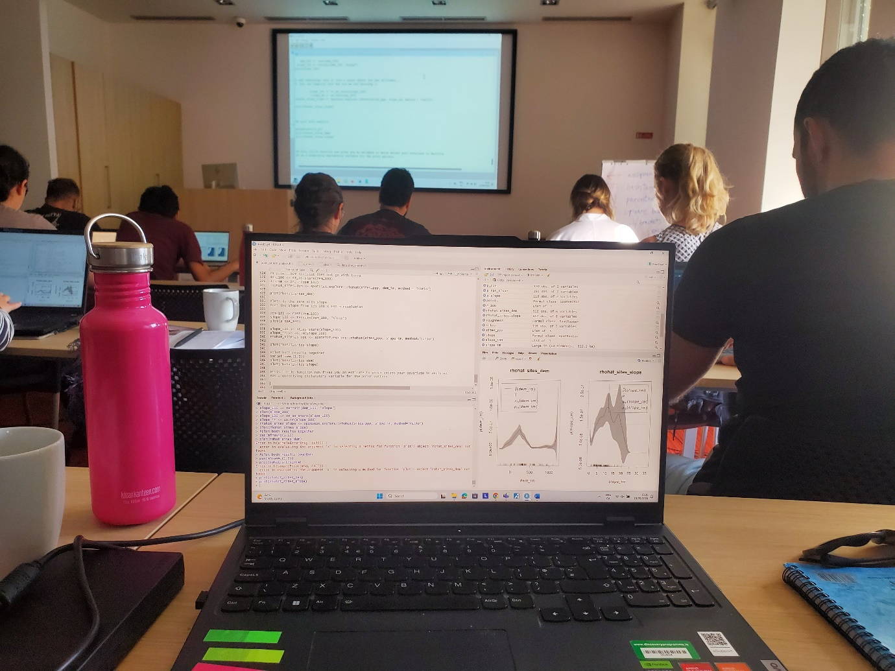

Image: Advanced spatial analysis in R

On day 4, I managed to do a quick walking tour of the city. Highlights included the Cathedral of St Peter and Paul, Villa Tugenhat and Špilberk Castle, including great views over the city from Park Hradu Špilberk.

Image: Cathedral of St Peter and Paul

Image: View across Brno from Park Hradu Špilberk

Image: A cold pint in the park with fellow R enthusiasts

On Day 5 we were divided into two groups, those who wanted to learn more at ARIADNE, AO-Cat and SPARQL, and those who wanted to work on a project of their choosing. I decided the to do the latter and began putting the R programming skills I acquired over the previous four days to good use on creating an interactive web map.

Since returning to work, I have completed the code for the interactive web map, although the content for this is still a work in progress. The map will provide a valuable spatial finding aid for a large collection of data from the [CHERISH project](https://cherishproject.eu/en/) that will be digital preserved and made available through the [Digital Repository of Ireland](https://dri.ie/).

Image: Preview of the interactive web map created for the purpose of providing a spatial finding aid directing users to the CHERISH data that will be held by the DRI.